Keshav Memorial Institute of Commerce and Sciences
(Affiliated to Osmania University) Narayanaguda, Hyderabad, Telangana.

Department of English activities (2019-20)

The Report on faculty development program organised by the dept of English.19/6/2019

One day faculty development programme on
"Emerging Trends in Research and Effective Communication for Quality Teaching"
organised on 19th June 2019 from 9 a.m. to 6:00 p.m.
120 faculty members from various colleges under OsmaniaUniversity participated in one day faculty development programme organised KMICSCS , the Chief Guest of the program was Justice lL.Narasimha Reddy and The Guest of Honour was Prof.T .Vijay Kumar, Head Department of English Osmania University. The resource persons were prof. Y.L.Srinivas ,Dr.K.W.Christopher, Dr.K. Parimala and Dr. Jacqueline. The first two sessions focused on critical thinking and research methodology and the second session was on effective communication for quality teaching. All the sessions were highly instructive and interactive. All the participants enjoyed the sessions and expressed the choice of the topics were very relevant and useful for the present day .The sessions drew to a conclusion with the valedictory session where the participants came to the conclusion that there is a need for critical thought after topics given as lessons to inculcate interest on research they felt the need for the faculty to develop their research capabilities the effective communication in the classroom is possible when the when the rush for the percentage of marks is not put on the shoulders of the students.More marks can be given to the teachers to assign as they assess their overall participation in the class-room.

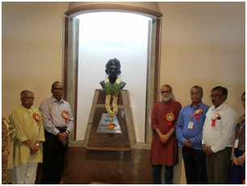

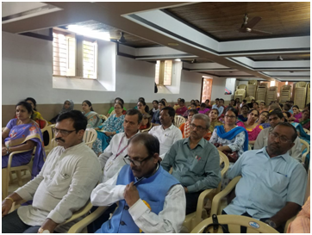

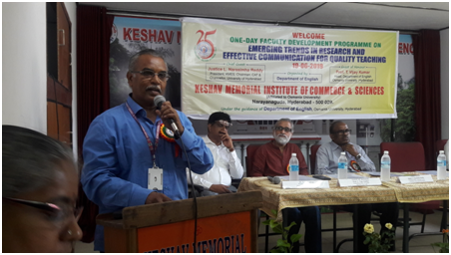
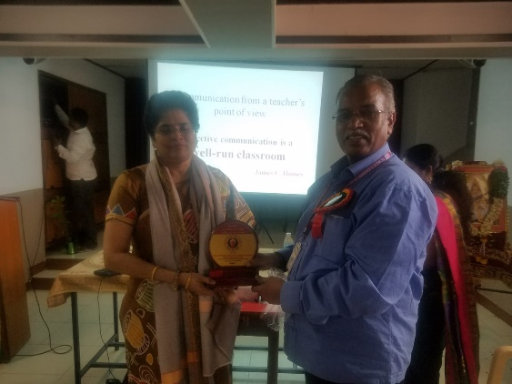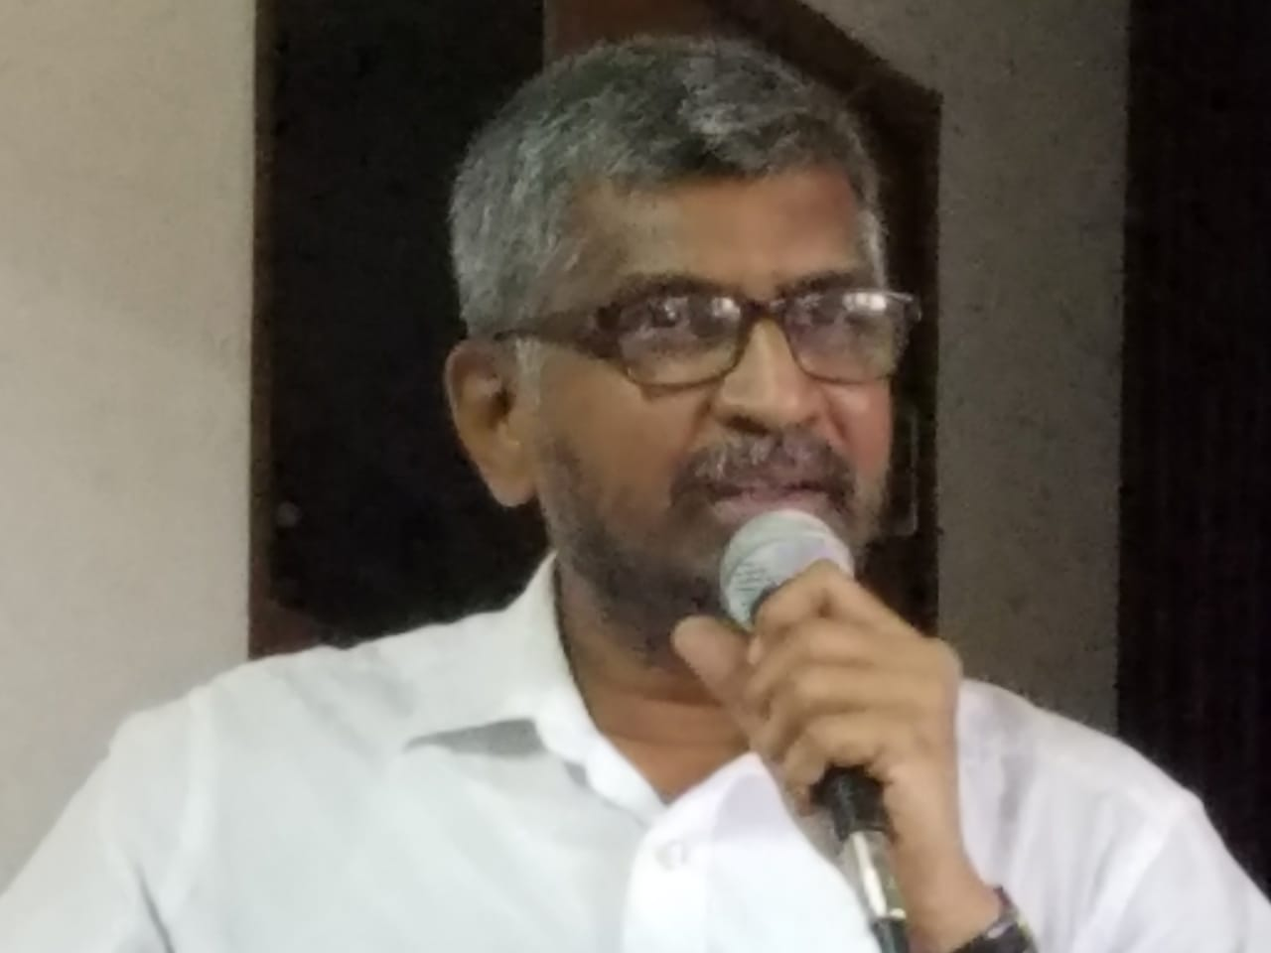
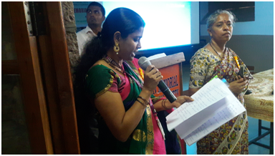
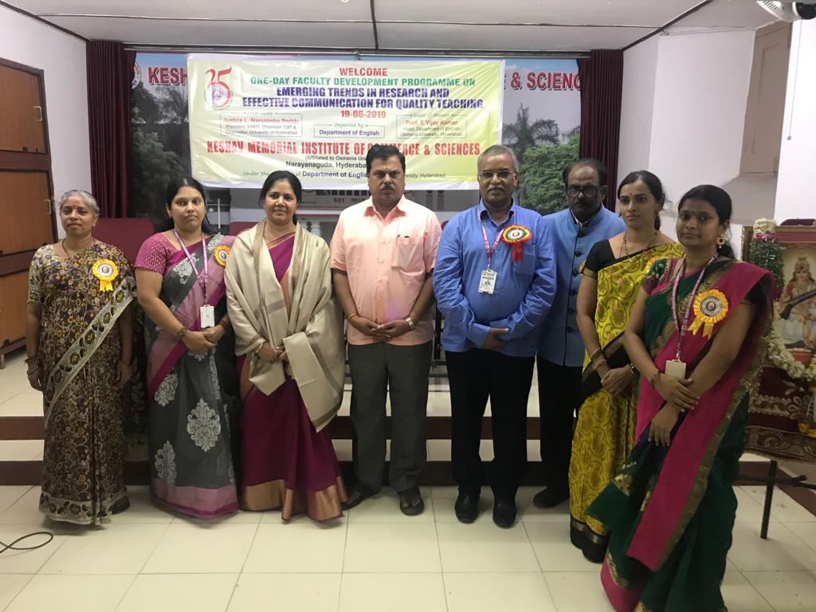

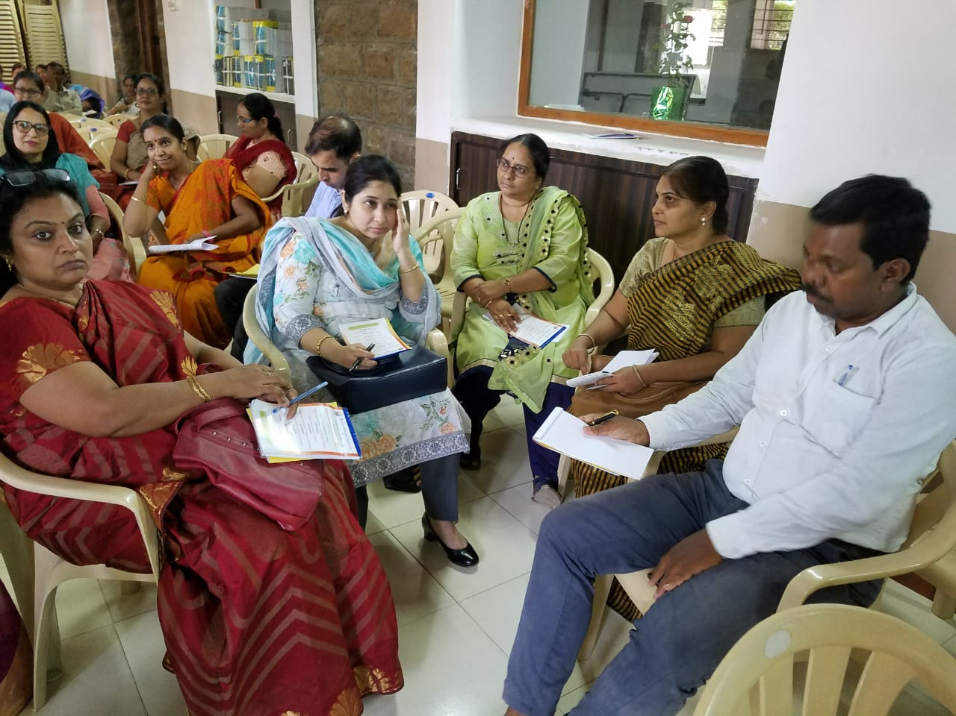
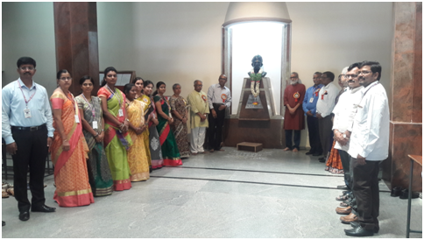

Keshav Memorial Institute of Commerce and Sciences
(Affiliated to Osmania University) Narayanaguda, Hyderabad, Telangana.

The Report on National Seminar organised by the dept of English.01/02/2020

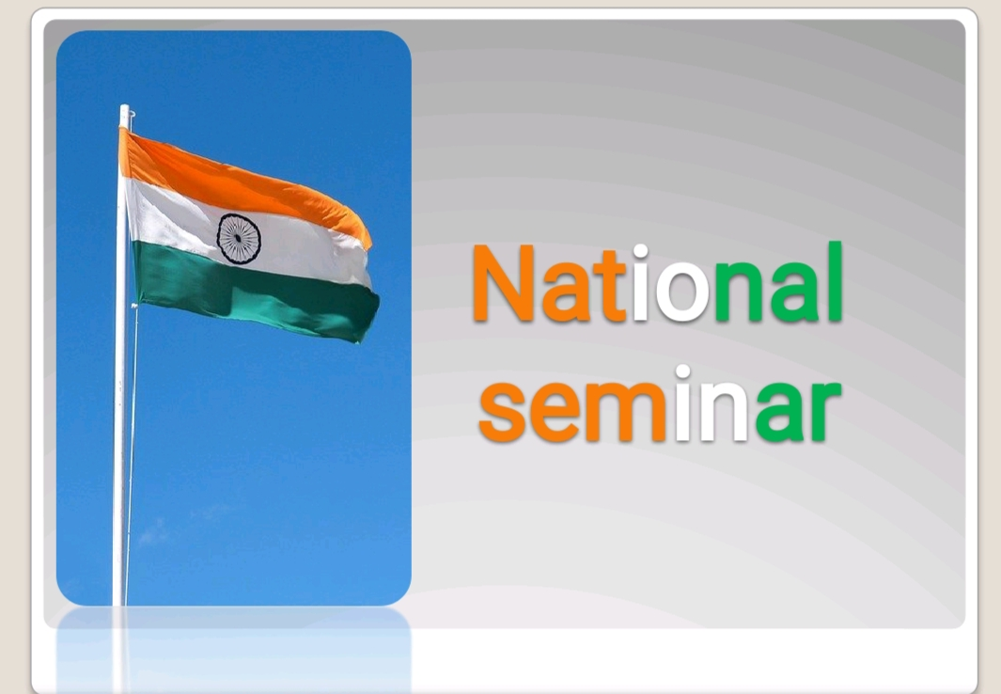
The report on one day national seminar on “Communication skills in the globalised world” held on 1st February2020 organized by The Department of English Keshav Memorial Institute Of Commerce And Sciences.

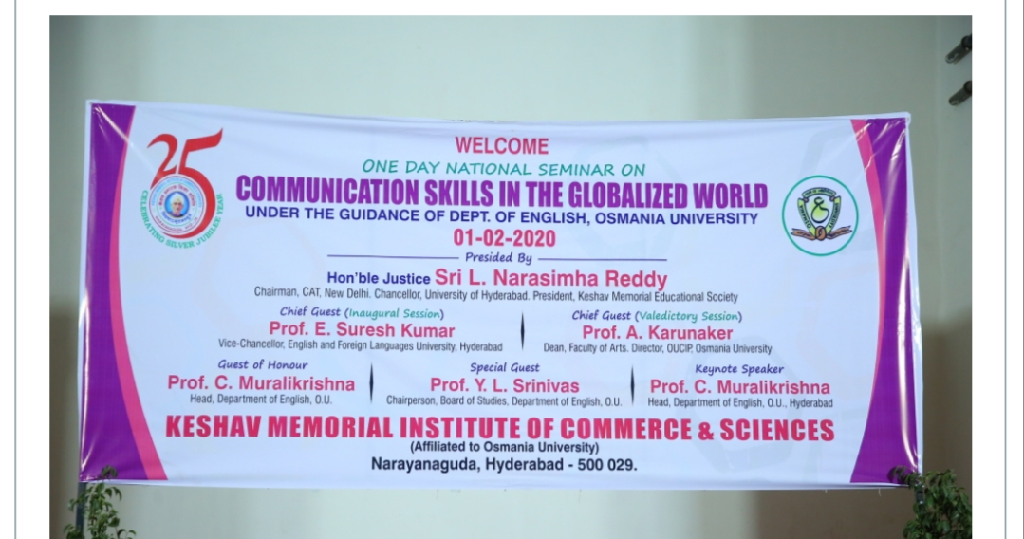

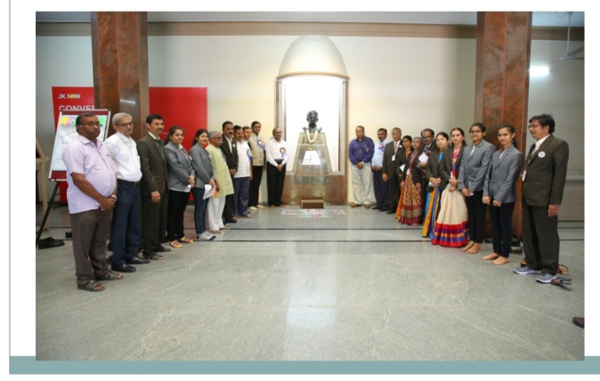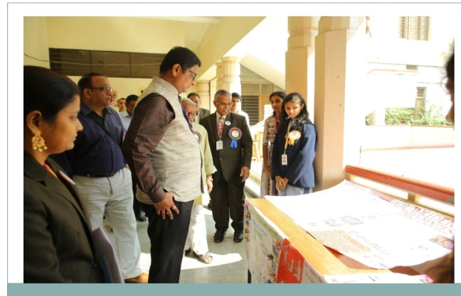

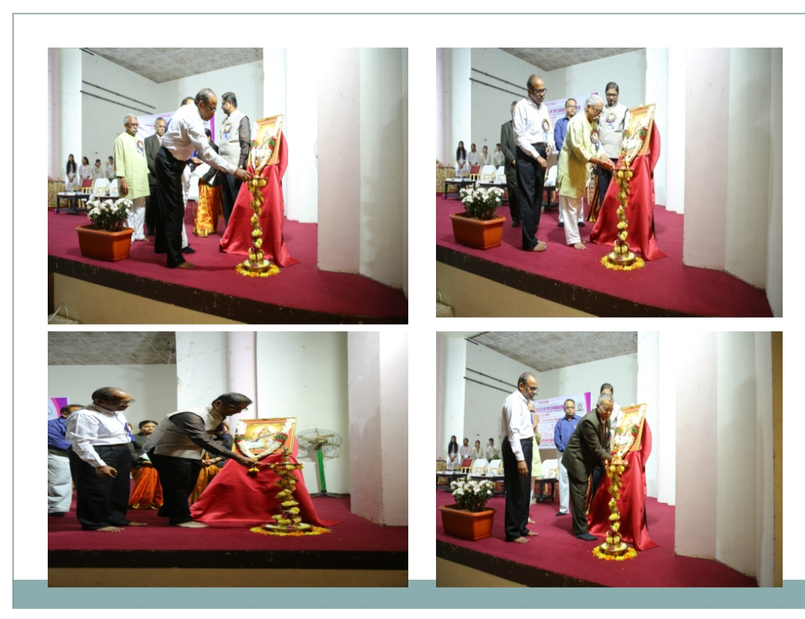

The Management Principal Staff and Students of the College are Happy with the success of this National Seminar. This is achieved only due to the guidance of Department of English Osmania University.
The President of Keshav Memorial Educational Society Hon’ble Justice Sri L.Narasimha Reddy Garu chairman, CAT, New Delhi, Chancellor University of Hyderabad inspired the Participants to sharpen their Communication Skills for achieving Success in any field.
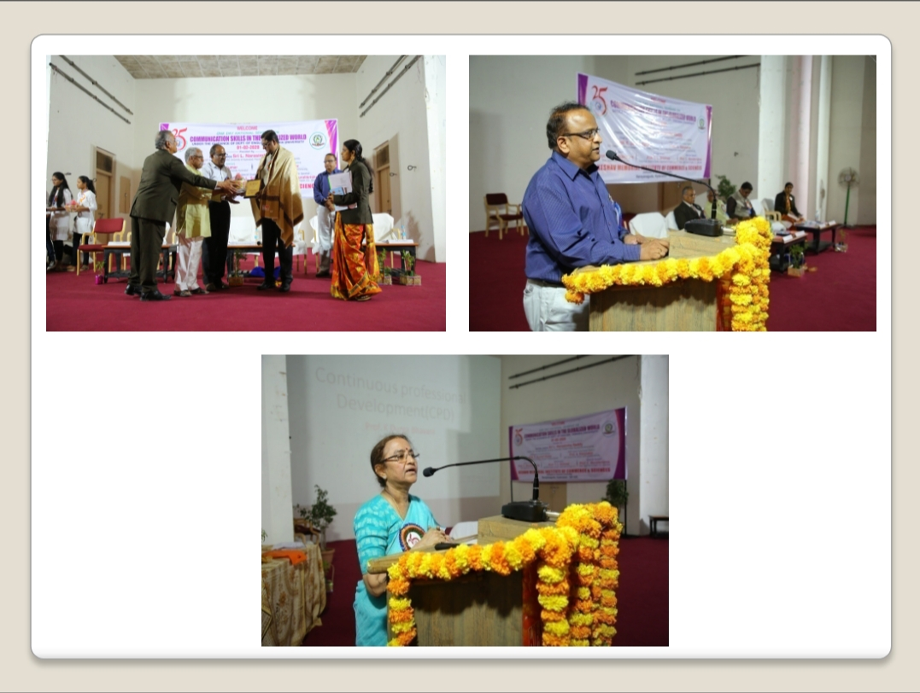
Prof.E.Suresh Kumar sir,The Vice-Chancellor, English and Foreign Languages University, Hyderabad was kind enough to grace the occasion as Chief Guest. Sir sensitized the need for sharpening the Communication Skills for achieving excellence in Professional and Personal Life.
Prof.C.Murali Krishna sir.The Head, Department of English, Osmania University in his key note address emphasized the need for 3Ds i.e., Discipline dedication and determination for sharpening Communication Skills.
Prof.K.Durga Bhavani Garu Retd.Chairperson, Board of Studies, Department of English, Osmania University the speaker of the plenary session enlighten the participants on the need for improving teaching skills for the benefit of all the stake holders.

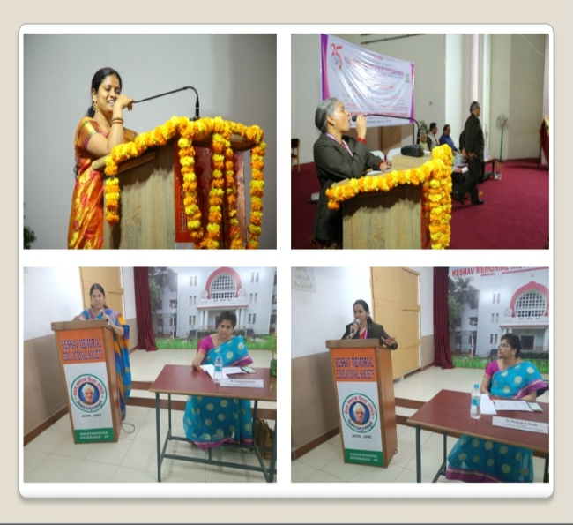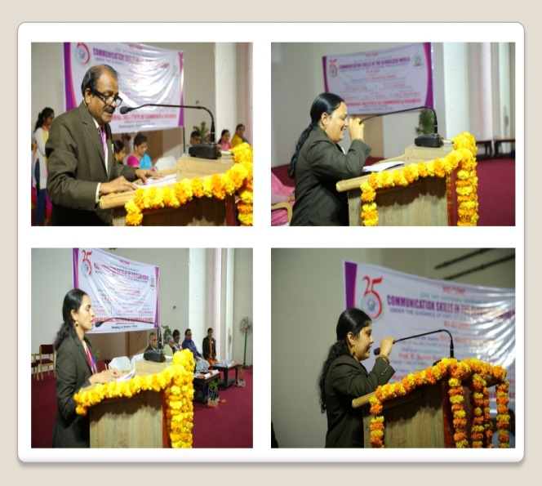
Faculty Members of various colleges and research scholars from different Universities presented their research papers in the seminar. The papers were presented in three parallel sessions chaired by Dr.Parimala Kulkarni, Dr.Jacqualine Amaral and Dr.Lakkaraju Mrudula

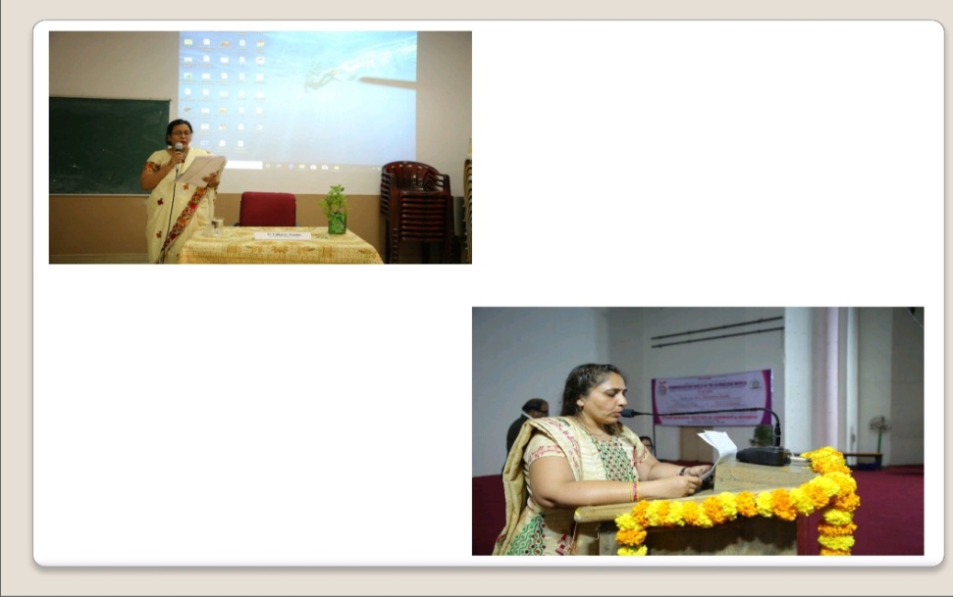
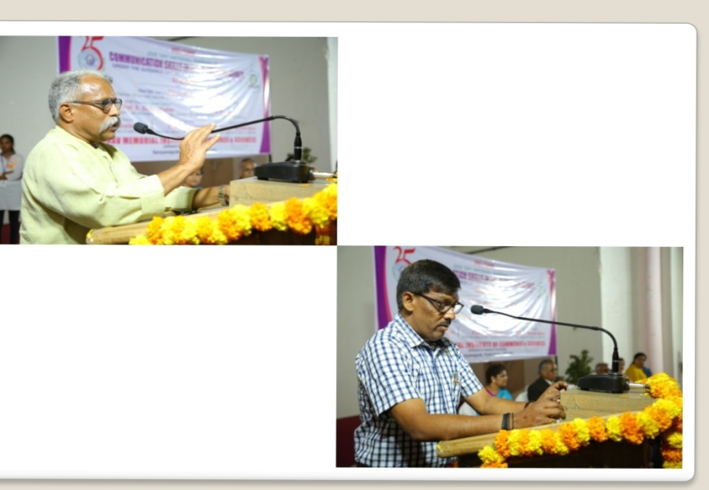
The chief guest of the valedictory session Prof.A.Karunaker Dean, Faculty of Arts, OUCIP, Osmania University was kind enough to grace the occasion as Chief Guest. Sir stressed on the importance of communication skills for the success of the teacher and the learner .he was kind to adress the gathering and distributed the certificates to all the participants.during the valedictory session the participants gave their feedback on the program and expressed that they werebenifitted bt attending this program it added knowledge on various topics relating to teaching and learning communication skills they wrer motivated to go for research into the area they presented their papers.
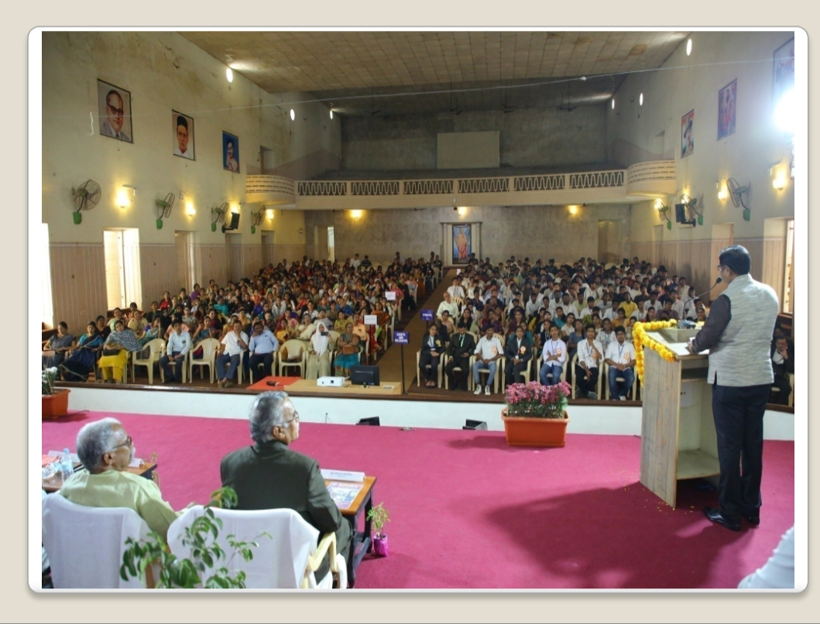

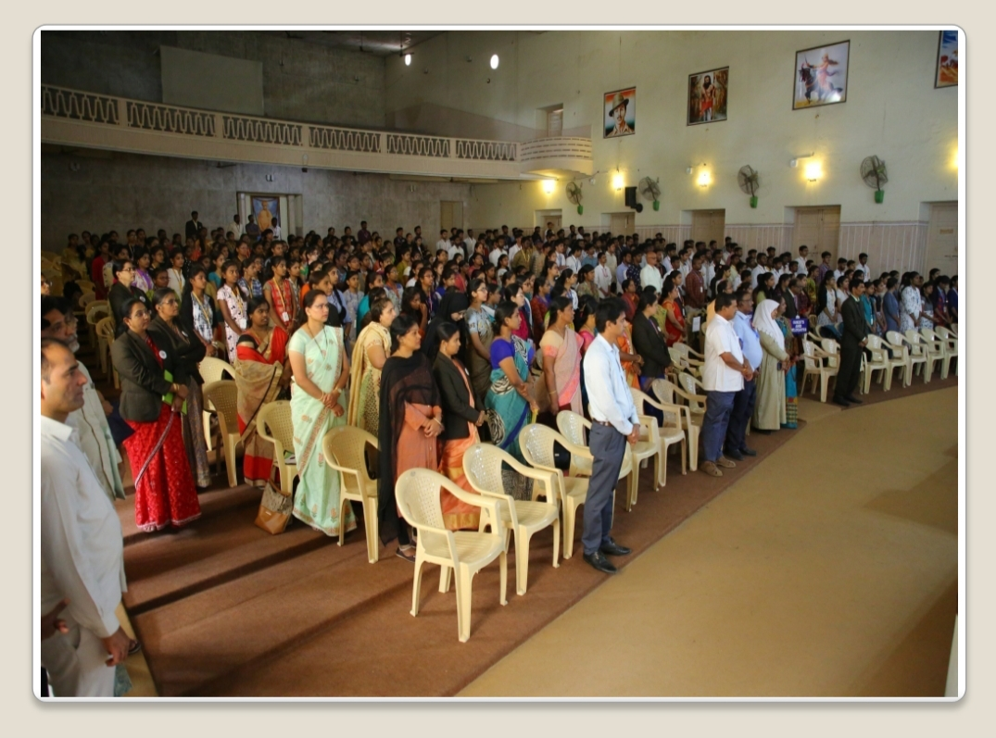
The students of this college maintained 100 percent Discipline and learnt the need to sharpen their communication skills to face the challenges of the globalization and grab the opportunities.
The Participants exhibited enthusiasm for the success of many more programmes to be conducted by this College. This College shall conduct several seminars under the leadership of the Principal Sri J.Nageswara Rao Garu and with the blessings of the Management and with the whole hearted Participation of Staff and Students. The program concluded with the vote of thanks extended by Mr.N.Parthasarathy.

